Name
Institution
Tutor
Date
Introduction and overview
Electric power distribution refers to the movement of energy that is electrical from a power plant. The connected lines through the poles are responsible for the transmission of this power. It became essential in the year 1880 when the generation of power at the substations began. The distribution systems were initiated in Europe and the United States of America cities mainly to be used purposely for lightning. In June 1880, transformers emerged to aid in transmitting power to vast areas and controlling the amount of energy. These made it grow at a first-rate, and by the 1880s, the electric power industry had been privatized by individuals and relevant stakeholders; this made it to earn more customers as its market grew.
Features of an electrical distribution system
The electricity generation starts from the station, where the voltage difference is perceived to be 33000 volts. At this stage, A.C. preferred as compared to D.C. Then, it is later distributed to the switchyard generating station where the transformer increases the voltage level from 44 Kv to 765 Kv, which is suitable for transmission purposes. At this stage, the electricity moves so quickly close to the speed of light.
Electricity distribution channels are categorized into two types; network and radial. The radial channel is organized in a manner that resembles a tree where each consumer has a single power supply source or origin. These types of power supply are common, especially in rural areas. In the case of the network type, there are several origins of power supply that operate in a parallel manner. They are applicable in areas that are loaded, especially in big towns that require high voltages of power (Shah, Shahil, and Leila PP.1142)
However, the radial systems also contain extremity connections where the structure can be resigned when a crisis might arise, such as planned routine Maintenance or a fault. It can be done using switches where one can choose to open or close them to distinguish different parts from the grid. The restructuring that is done through functional exchange between the components of a system portrays or shows one of the essential strategies that tend to better and improve the performance of the distribution system. Since the transmission wires are overhead, then that is a clear indication that they rely on the air for insulation. When there are also high winds or heavy rainfalls, then we are likely to have power outages.
Nevertheless, a complete electrical distribution system consists of three major elements. They include distribution system, generation or production, and a voltage grid transmission. The substations are normally equipped with the monitoring types of equipment. This is so because the switchgear and the auxiliary need to be activated remotely (Leibman, Michael, and Gregory Scott).
The electrical distribution systems play a significant role in the power system because it's considered the final stage of electric power delivery. The issued network must transfer the power from A.C. to D.C. power source, where it is likely to be utilized. A comprehensive distribution system has feeders that connect with the local generators to lower the voltages from high to a medium voltage that ranges from 3kv to 36kv with the help of the transformers. This substation contains the circuit breakers and some switches, making them disconnect from the transmission grid (Rahmani, Mehdi, and Mahmud PP.2005).
The dispersal lines carry this average voltage power to the nearby transformers that later distributes power. These transformers also are responsible for the lowering of the voltages. So that the power can be used by individuals for lightning purposes or home appliances such as fridges, watching T.V., The service drops are used to connect the commercial and residential consumers to one primary transformer with the help of the secondary lines. Consumers who might need a much higher electricity level will have to be connected directly to the sub-transmission level. The consumer receives power through the use of a service drop, and in some cases, others might receive it through the meters.
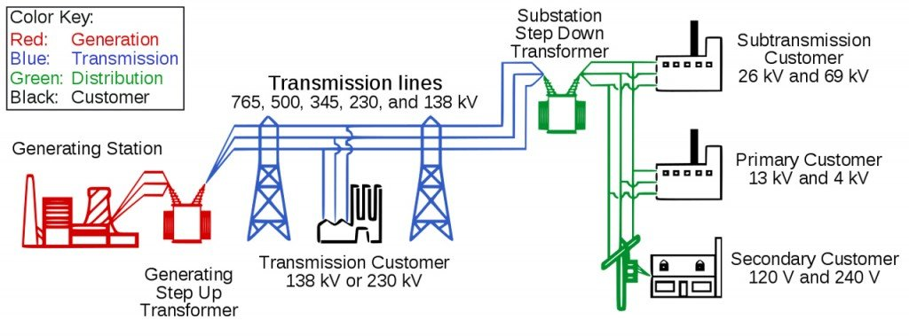
According to Markard and Jochen (pp.323), the electrification process in the rural consumes higher voltages, especially during the distribution due to the long distances that they tend to cover. The number of poles is minimized and reduced hence resulting in high energies. This encourages and allows the use of the steel wire that is galvanized by steel wires. These wires allow for the spacing between the poles to be quite long from each other. It is hence saving on costs and expenses that might have occurred in the course.
Electrical component symbols used in circuit diagrams
Electrical symbols refer to the pictures or components that represent different devices that used electronically. These components may include wires, resistors, batteries, and even transistors. The responsible international bodies normally standardize these symbols. Despite being regulated, they still differ from one country to another.
Whether they are considered robust or straightforward, most electrical symbols get a unique way to describe them. Unlike other diagrams, the circuit diagram clearly illustrates the actual electrical connections made. Currently, the circuit symbols have been standardized by the relevant bodies making it easy for the people who are studying or going through these diagrams and realize the pictures work.
Schavemaker, Pieter, and Lou Tell us that through the use of Schematic Circuit symbols, the engineers have found it easier to briefly convey the circuit information without causing any issue or complexness. It takes the shortest time possible to learn and understand what are the symbols mean and represent. It is also imperative when coming up with a circuit diagram to recognize individual elements.
Most of these components get marks for identification purposes in the circuit board, and when damage or failure arises, it makes work easy to identify and repair where necessary. The symbols have made it easier to develop or create a diagram and, most importantly, have the descriptions easy to understand, hence reducing all the possible misinterpretations that could have occurred. Students are the most preferred group that should understand how the circuit diagrams function. Diagrammatic representations can play a significant role in understanding the principles of electricity as they equip them with the necessary knowledge. Below is a table that represents the meaning of each symbol and component. Here is a perfect symbol for the emergency stop button.

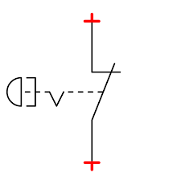

Sign | Name of the element | The description
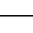 | Transmission wire | Used as a conductor especially in the flow of electric current
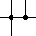 | Combined electrical wires | Contact of the wires
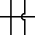 | Unconnected wires | Unconnected cables or wires
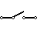 | Toggle controller SPST | When it is open, it automatically disconnects the flow of current.
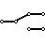 | Toggle key SPDT | Chooses double connections
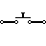 | Opening Controller or switch | Responsible for opening
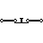 | Closing controller | It is used for routine closing.
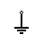 | Earthing | They are used for zero potential reference and electrical shock protection.
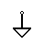 | Normal ground
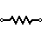 | IEEE resistor | Regulates the amount of current that is flowing.
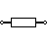 | IEC resistor | Regulates the amount of current that is flowing.
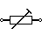 | Circuit breaker trimmer | Preset resistor
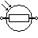 | Photoresistor / Light-dependent (LDR) | Ensures changes especially resistance towards the light
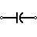 | Capacitor | It is responsible for storing the dynamic changes that might have occurred.
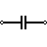 | Capacitor
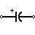 | Polarized diode | Electrolytic diode
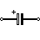 | Polarized diode | Electrolytic diode
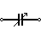 | Variable capacitor | Adjustable capacitance
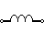 | Inductor | Responsible for the generations of magnetic fields
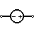 | Sources from the voltage | Production of voltage that is stable and continuous
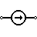 | Origin of power | Source of power
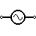 | A.C. Voltage Source | A.C. voltage source
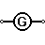 | Substations or a generator | The mechanical rotation of the generator generates an electrical voltage.
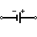 | Battery Cell | Producing constant levels of voltage
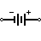 | Battery | Producing constant levels of voltage
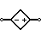 | Controlled Voltage Source | Produces and supplies voltage as a function current of other circuit elements.
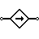 | Controlled Current Source | Generation current mainly a function of voltage and other circuit elements.
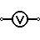 | Voltmeter | It measures voltage levels. When connected in a parallel manner, there is higher resistance.
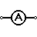 | Ammeter | It determines the electric current. When connected in a series manner, it has zero resistance.
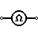 | Ohmmeter | Its main work is to determine the resistance.
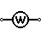 | Wattmeter | Responsible for measuring and determining the electric power
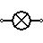 | Bulb | When the current flows, light is produced.
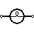 | Bulb | When the current flows, light is produced.
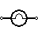 | Bulb | When the current flows, light is produced.
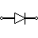 | Diode | It only allows the flow of current towards a single direction.
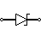 | Zener Diode | Here, the current can flow in the opposite direction.
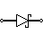 | Schottky Diode | It is a diode that contains lower voltage levels.
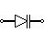 | Varactor / Diode
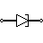 | Tunnel Diode
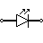 | Light Emitting Diode (LED) | Produces light when there is a flow of current.
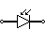 | Photodiode | There is a flow of current only when exposed to the light.
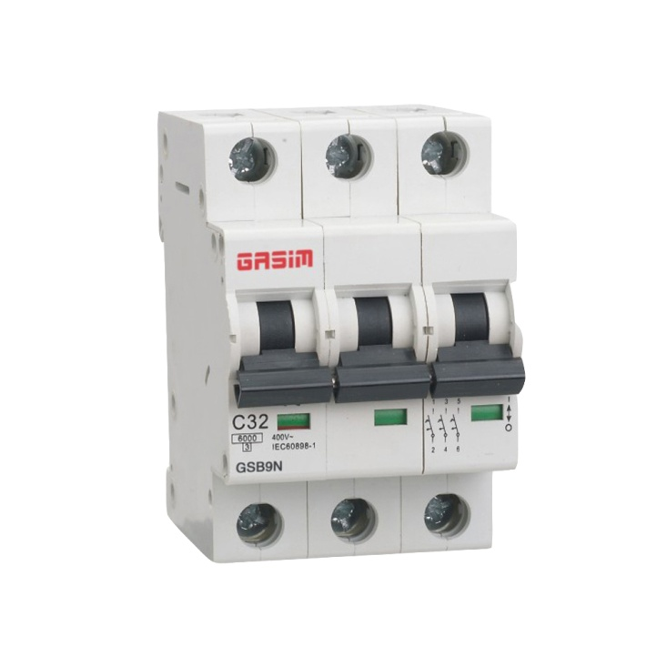
Shown above is an image of a circuit breaker.

The table above has summarized all the symbols used in the diagrams. Primarily during the power distribution and their meanings as well as the function they perform.

Different methods of single and three-phase connections
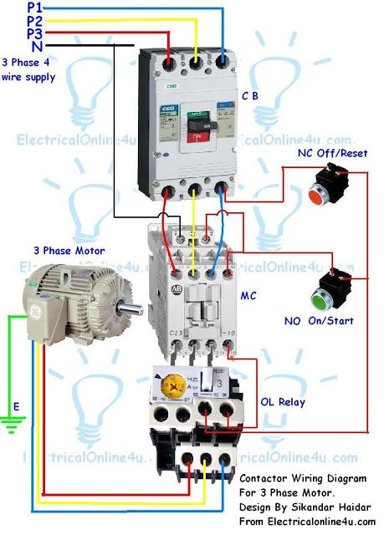
According to Wang, Chengshan, and et al. (pp.305), the supply of power is categorized into two types. Single-phase is the supply of energy using a single conductor, while a three-phase refers to power distribution using three conductors. In the case of a single-phase power supply, only one A.C. current is transmitted or supplied through one wire, while on the other side of a three-phase, three wires carry the alternating current. Below is a summary of three phase connections in the transformer.
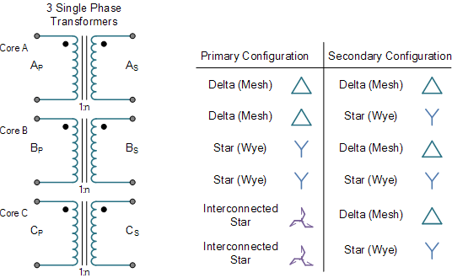
Under normal circumstances, the single-phase utilized in regions or parts with lower levels of consuming electricity such as homes and schools. The three phases have always got the upper hand in areas or things that consume more power, such as industries. In the single-phase, the maximum voltage is 230V, while 415V is the maximum voltage in the three phases of the power supply. These are a clear indication that power transfer capability is minimum in a single stage while it is maximum in a three-phase
However, single-phase is prone to more problems. Because it has only a single-phase wire, so if there arises any faults or inconveniences, then there will be no power supply. Unlike the three-phase, it has more phases, so if any failure occurs, the power supply will continue because the other stages act as a backup. Also, the single-phase regarded to be more expensive because it requires Maintenance from time to time, while the three-phase does not require Maintenance, not unless there is a failure in the phases.
In the single-phase 230V of the power is consumed across the globe. Because of a single-phase system, the voltages tend to differ in the same sinusoidal pattern. This is why it is mostly used to serve residential areas and parts. While, on the other hand, the three-phase electrical system its sinusoidal voltage curve or pattern varies at 120 degrees from each other.
The generation of power at any given power station is usually a three-phase produced at very high voltages and then taken to the load centers. The transformers are then used to step down these voltages from high levels to medium. The single-phase lacks the capability of supplying continuous power. This makes it less ineffective when it comes to providing electricity to industries hence making it inferior as compared to the three-phase, which is considered to be more steady and efficient in terms of power supply to big factories that consumer power.
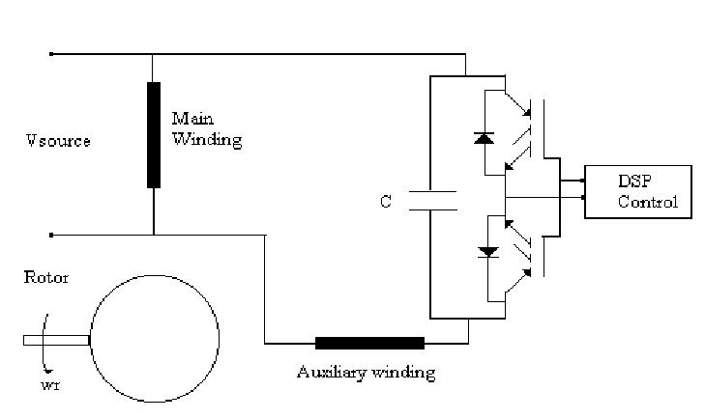
Single phase induction motor switching capacity is shown in the above diagram
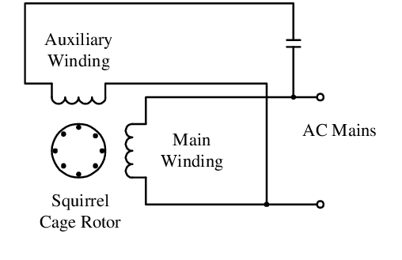
Above shown is the run single phase induction motor

Sources Cited
Baillargeon, Jeremy Robert, et al. "Electrical device, electrical distribution system, and methods of assembling same." U.S. Patent No. 10,164,387. 25 Dec. 2018.
.King, D. J. M., et al. "Predicting the formation and stability of single-phase high-entropy alloys." Acta Materialia 104 (2016): 172-179.
Leibman, Michael A., and Gregory Scott Brewer. "Systems and methods for assigning groups of antennas of a wireless power transmitter to different wireless power receivers, and determining effective phases to use for wirelessly transmitting power using the assigned groups of antennas." U.S. Patent No. 9,900,057. 20 Feb. 2018
Rahmani-Andebili, Mehdi, and Mahmud Fotuhi-Firuzabad. "An adaptive approach for PEVs charging management and reconfiguration of the electrical distribution system penetrated by renewables." IEEE Transactions on Industrial Informatics 14.5 (2017): 2001-2010
Markard, Jochen. "The next phase of the energy transition and its implications for research and policy." Nature Energy 3.8 (2018): 628-633.

Schavemaker, Pieter, and Lou Van der Sluis. Electrical power system essentials. John Wiley & Sons, 2017.
Shah, Shahil, and Leila Parsa. "Impedance modeling of three-phase voltage source converters in D.Q., sequence, and phasor domains." IEEE Transactions on Energy Conversion 32.3 (2017): 1139-1150.
Wang, Chengshan, et al. "Optimal siting and sizing of soft open points in active electrical distribution networks." Applied energy 189 (2017): 301-309.
.

